**Lecture Notes**

**Learning Outcomes**

1. How to create and set up a new iOS project from scratch
2. Get an overview of Xcode – the software for creating iOS apps
3. How to design your app in Xcode using iOS components
4. How to incorporate your own image assets into your app
5. How to design and create a custom app icon
6. How to run your app on a Simulator and the iPhone

**XCode Storyboards and Interface Builder**

* Don’t confuse the main storyboard and the LaunchScreen storyboard.

They look exactly the same – but in the launchscreen this is the part where you can design what the user sees in the first moments that your app gets launched.

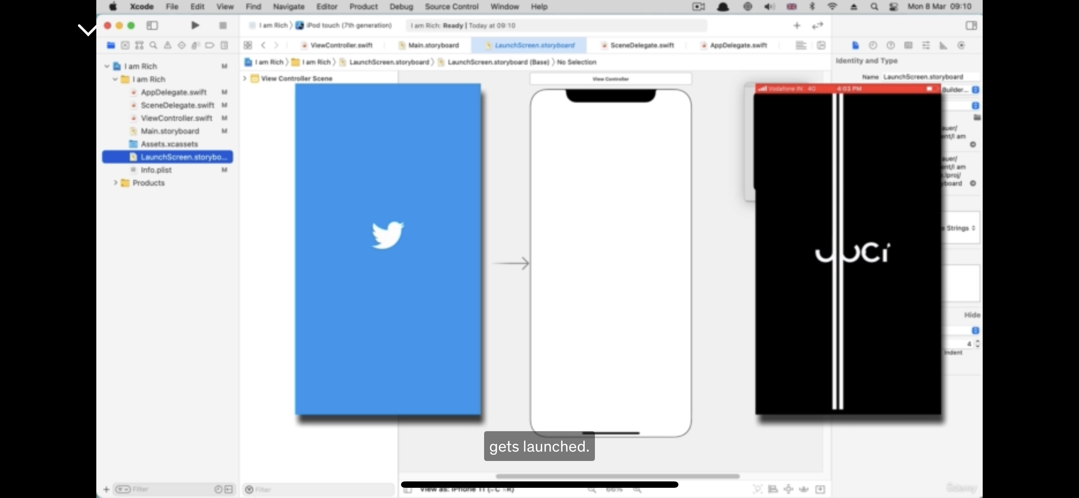

* Like a company logo, or a Loading screen.
* For color palettes, go to colorhunt.co

Positioning in Xcode

* For iPhone screen sizes, go to paintcodeapp.com you can find iPhone resolutions defined as **Points.** Why is it Points and not pixels? As the resolution of the iPhones improve, they managed to cram more pixels into the same screen size. If we look at iPhone 2G / 3G, then 320 by 480 points is literally 320 by 480 pixels.
* For the iPhone 4, they managed to double the amount of pixels crammed into the **same screensize.**  So the screens are still the same, but now we have doubled the resolution to make the images much sharper.
* In a typical screen, the **top LEFT** corner is the origin, and the position of the screen width and height is defined by **POINTS** (not pixels).
* The position of every element would also be **its top LEFT corner.**

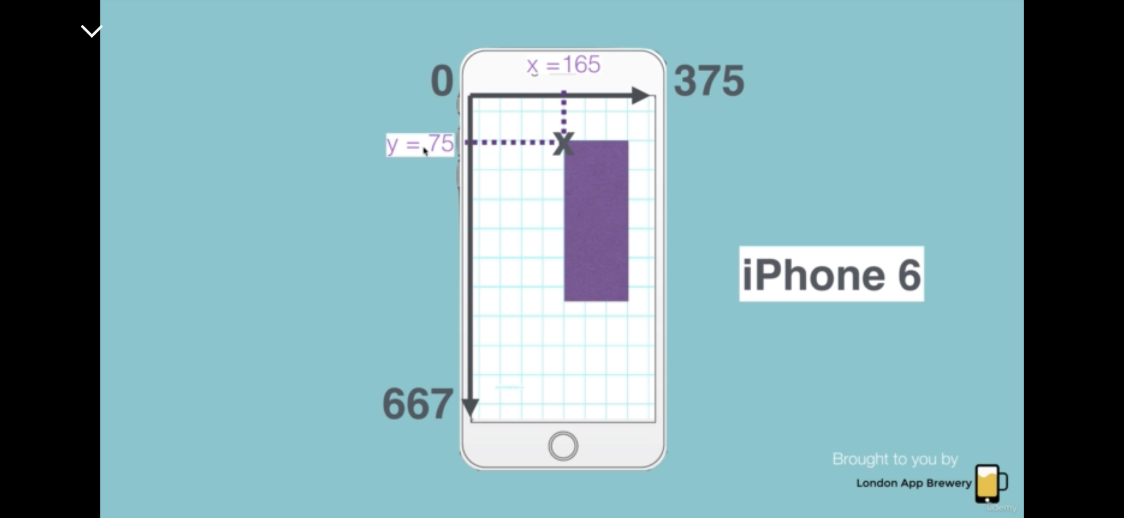

**Image Assets (UI Image View)**

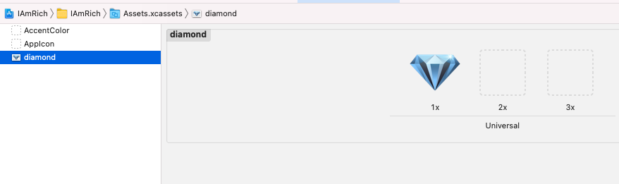

* Diamond is our own custom image.
* What is this Universal (1x, 2x, 3x)?
* 2x image has 4 times as many pixels than the 1x image.
* 3x image has 9 times as many pixels than the 1x image.

How do we create images of all three sizes?

Well if we start with an image that is 300 by 300 pixels, and then you would save it as the 3x version, then scale it down to 200 by 200 pixels, and that save that as the 2x version. Then scale it down to 100 by 100 pixels, and then save that as the 1x version.

So if your 3x version is 300 by 300, the maximum size that you can actually use in your app is going to be 100 by 100, because eventually, what’s going to happen is that the iPhone depending on where its being displayed, then it will scaled down into the 1x image. If a large image is squeezed into smaller space, its going to look a lot sharper than the one that only has 100 by 100 pixels to display.

When you are creating assets for your app, you can either do it manually, or if you’re using software such as sketch or illustrator, then you have existing tools that allow you to export images in their 1x, 2x and 3x sizes.

Alternatively, you can try appicon.co/#image-assets

**Creation of App Icons**

* Go to canva.com and create a canvas of **Custom Dimensions** (1024 by 1024).

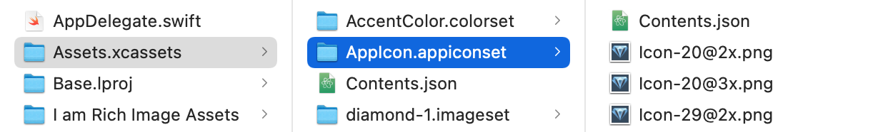

**Under the hood**

Notice that the naming convention has been copied by AppIcons.co

* Content.json **arranges** all the icons in the correct placeholders.
* The one that we downloaded from our app icon generator also has a Contents.json.

So if we replace our current **AppIcon.appiconset** folder we will have all the images in the right placeholders without any added work on our part. **NOT THE assets folder!!**

**Running your App on Your iPhone**

6 step process:

1. Check XCode and iOS versions match
2. Add an Apple Developer Account
3. Sign the app with your name
4. Connect physical device
5. Trust yourself
6. Build and run your app

**Step #1 – Check XCode and iOs versions match**

What do we mean by match? Check that your XCode **version** (12.4) supports iOS 14.4.